**Opening a Restaurant in Chicago**

Mehdi Mashayekhi

March 29, 2020

**Introduction**

**Background**

Chicago is one of the metropolitans in the United States. It had a population of 2.716 million people in 2017. It had 55 million visitors in 2017. All of these numbers make the city a great place for restaurant industry. Many famous celebrities, Hollywood actors and actresses have opened a restaurant in the city. Michael Jordan is one the most famous people who has a restaurant in the city.

**Problem**

As mentioned above, the restaurant business in Chicago is very promising. There are more 7,300 restaurants in the city. There are already some established ones where celebrities go to very often. Although the city is very big, most of the successful restaurants and sights are located near S Michigan Avenue. This makes it very hard to open a successful restaurant or any other successful business near S Michigan. Therefore, in this project, we want to find a promising location to open a restaurant. In addition, we want to identify which type of restaurant could be successful in that location, for example, Italian, Chinese, Mexican etc.

**Data**

The data source for this project is FourSquare API. They increased their database by using user reviews. It has more than 55 million users. Many other services use FourSquare for their maps. The API has many useful features for the free version of the developer account. You can make 950 regular requests and 50 premium ones per day which are more than enough for the project. One major benefit of the API is that it has a variety of search queries, such as type of restaurants which is exactly what we need for this project.

**Methodology**

As we mentioned before, we are interested in opening a restaurant in S. Michigan Ave. in Chicago. We used FourSquare API to get the restaurants near that are. The output of the API is a Json file. Here are all the restaurants near the area. There are 30 restaurants in total.

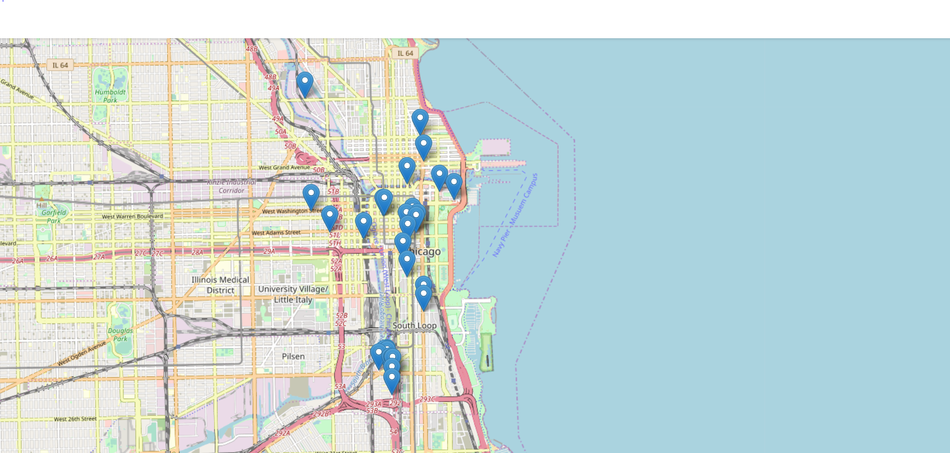

**Results**

There was a major problem with the file downloaded from the API. The file does not clarify types of each restaurant at first glance.

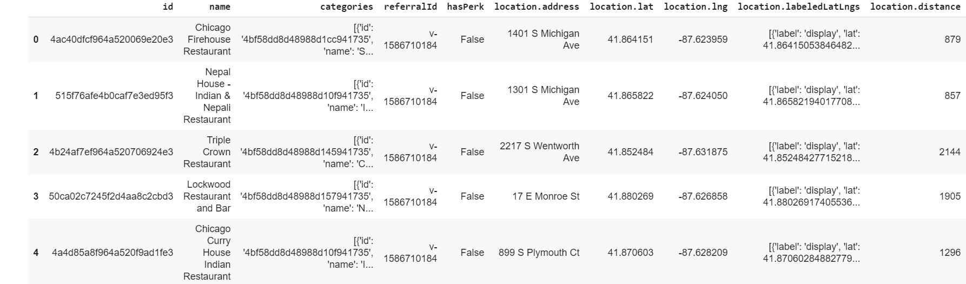

As it is shown, only the names of the restaurants were available and we could not say if a certain restaurant is Spanish, Italian, etc.

**Discussion**

To tackle this issue, we downloaded another file separately to check if we could add the types of restaurants instead of the categories. Here are the results:

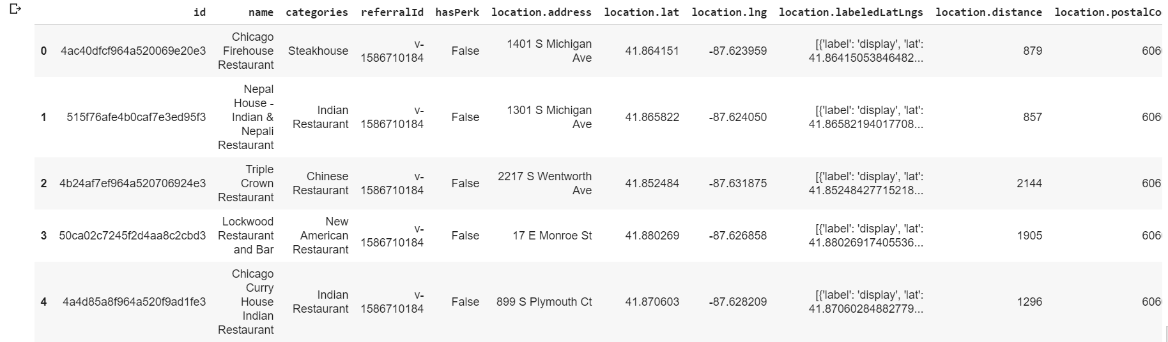

As you can see, under the categories column we could now see if the location is a steakhouse, Chinees, Indian, Bar etc.

Now, we check the number of each type of the restaurant in the neighborhood.

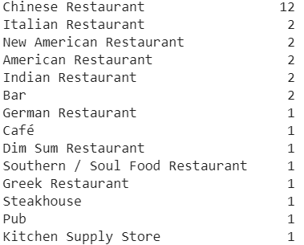

**Conclusion**

Obviously opening a Chinese restaurant in this area would be a mistake or an opportunity. It could be a mistake because there are already too many competitions in the area. On the other hand, this shows that Chinese food is very famous in that area. Therefore, opening another restaurant could be promising. In addition, there are no Spanish nor Persian restaurants in that area. Opening these types of restaurant could be very promising because of the lack od competition.